# CS 255 System Design Document Template

This template lays out all the different sections that you need to complete for Project Two. Each section has guidance to prompt your thinking. You will need to continually reference the interview transcript as you work to make sure that you are addressing your client’s needs. There is no required length for the final document. Instead the goal is to complete each section based on what your client’s needs are. Remove this note when you are finished, and replace all bracketed text with the relevant information.

## UML Diagrams

### UML Use Case Diagram

### UML Activity Diagrams

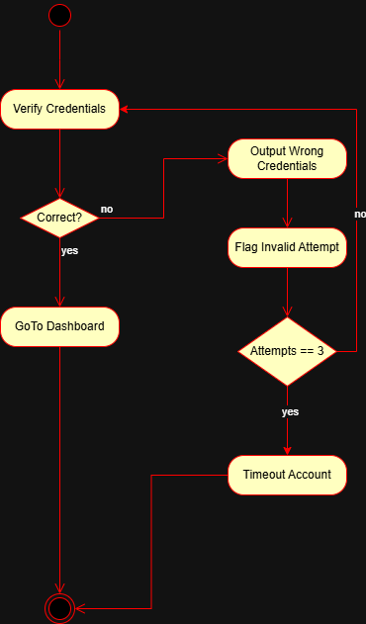

### UML Sequence Diagram

### UML Class Diagram

## Technical Requirements

The system will run on a cloud based server utilizing a cloud provider such as Azure, AWS or Google Cloud, so any client that can run a modern browser can access the system. Implementing responsive design, and adhering to optimization for mobile devices will ensure a seamless user experience across devices. A relational database such a PostgreSQL will ensure that data is linked to the correct user. For example, the feedback table should have a key for the student identification number, so the instructor can write feedback to a particular student and the student can view the provided feedback using queries to the database based on the identification number.